 VINOD SIR’S GROUP TUTION

MARKS: 20 MATHS-2 TIME: 1 Hr. 30 Mins.

Q. 1: Do as directed: (Each sum contains 2 marks) [8]
1. Base of a triangle is 9 and height is 5. Base of another triangle is 10 and height is 6. Find the ratio of areas of these triangles.
2. 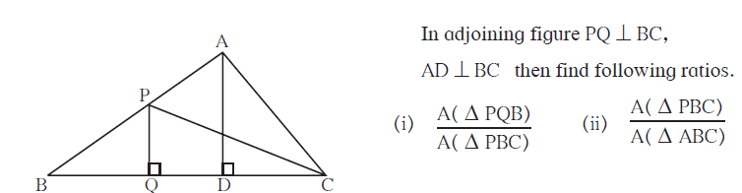
3. 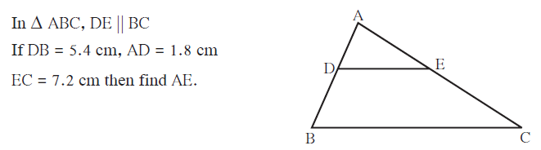
4. 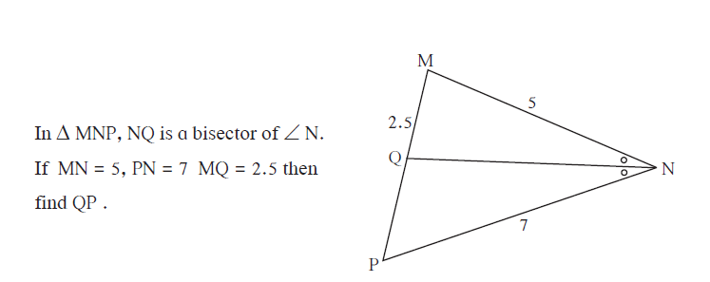

Q. 2: Do as directed: (Each um contains 3 marks) [12]
1. 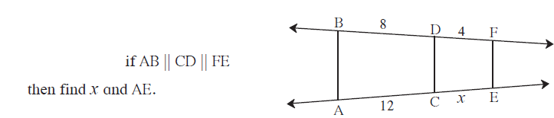
2. 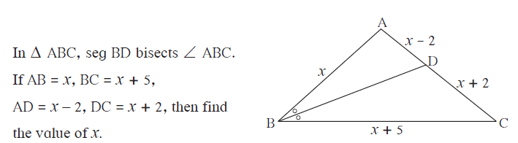
3. 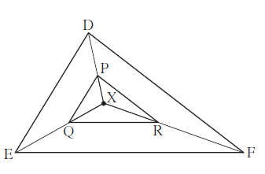
X is any point in the interior of triangle. Point X is joined to vertices of triangle. Seg PQ || seg DE, seg QR || seg EF. Fill in the blanks to prove that, seg PR || seg DF.

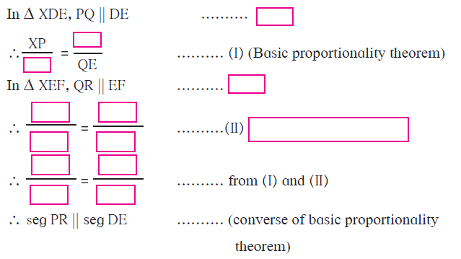
4. 